Backyard Mission
………repairing homes, restoring hope.

Mission Statement:

1. Get people warm and dry by providing free home repairs, using volunteer labor and buying materials with donated money. Demonstrating the love of Christ!

2. Give Christians/Service groups the opportunity to put their faith into action by loving and serving their neighbors.

3. Help other churches start a Backyard Mission program. ____________________________________________

21 years of “loving our neighbors”

It was 21 years ago, in September of 1992; that we roofed out first Backyard Mission home. Because God has continued to provide all we need, we are blessed to still be doing it today.
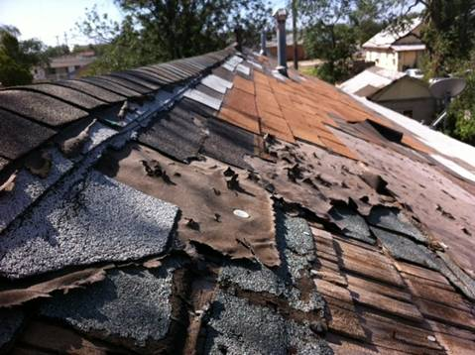
These are pictures of a roof I measured last week. The family is doing the work themselves, and I’m pretty excited about that. It has 2-3 layers of composite shingles over a wood shingle roof.
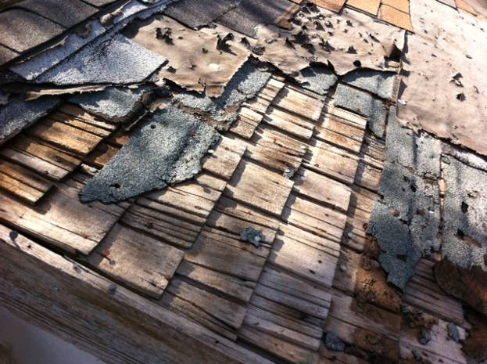
It has been a great adventure for 21 years, and we look forward to whatever God has planned for the future of Backyard Mission.
SEPTEMBER 2013

Projects to date - 1075

THE UNEXPECTED BLESSING OF “JOY”!

By God’s grace, Backyard Mission has grown tremendously in the last 21 years. As more of the “hands on” work is done by volunteers, I have to be careful not to get so focused on “running the machine”, that I lose sight of who we are serving. So, I make sure that I still do the home visits of the families who are working on their own homes. I rarely get surprised these days, but while doing a home visit last Thursday, it happened. I received the unexpected blessing of JOY!


“Joy” is a parrot! During my visit, she chatted, whistled, laughed, and squawked in typical parrot fashion. But when we went into the living room to complete our paper work, the surprise came. Joy burst into song! Not typical bird singing, but she sang in opera style with full, perfect vibrato! I was laughing so hard, we could hardly complete our paper work. Joy is true to her name………she brings the unexpected blessing of “joy” into that home.

Thanks for the surprise, Lord. ☺

YOUR PARTNERSHIP WITH US MAKES IT POSSIBLE FOR US TO DEMONSTRATE THE LOVE OF CHRIST TO OUR NEIGHBORS!

Board Members:

Jim Taylor (chrmn) Jackson Ashburn Lindy Fruge’ Darrel Goss

Glenn West

LAURIE FOSTER, Founder/Director
8205 Quincy Ave (806) 300-0184
Lubbock, TX 79424
Lfoster@backyardmission.org / www.backyardmission.org

2012-2013 Grants
Betenbough Homes. Monty Miller Living Legacy. LeGrande & Cassandra Northcutt Donor Advised Fund at East Texas Communities Foundation, Chester & Ada Ruth Green Charitable Endowment, Mrs. Fern Cone Endowment, Roy & Lela Furr Fund, C.R. & Virginia Hutcheson Charitable Fund, Hassel Endowment, Horizon Fund and Gladys Leftwich Endowment, W.B. & Mozelle Rushing Family Endowment, and H.D. Snell Endowment, of Lubbock Area Foundation, and LAF charitable funds.

