Backyard Mission Newsletter…do the Word.

Mission Statement:

1. Get people warm and dry by providing free home repairs, using volunteer labor and buying materials with donated money. Demonstrating the love of Christ!

2. Give Christians the opportunity to put their faith into action by loving and serving their neighbors.

3. Help other churches start a Backyard Mission program in ____________________________________________

At the end of this day, lives will be changed! It always happens this way.

It is a scene I know well……….a covered trailer with the back flung open, tools scattered in the yard, and volunteers buzzing around a house like bees on a hive.

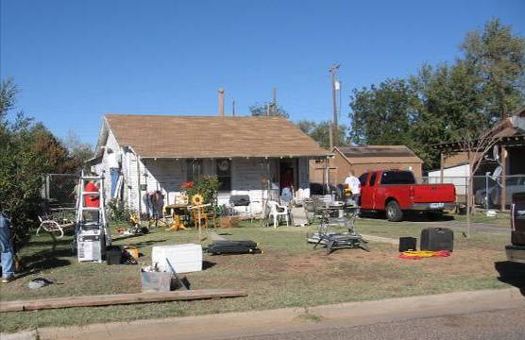

Everyone expects the homeowner to be blessed, but the volunteers are sometimes surprised to find the blessing is two sided. Their lives are changed as well.

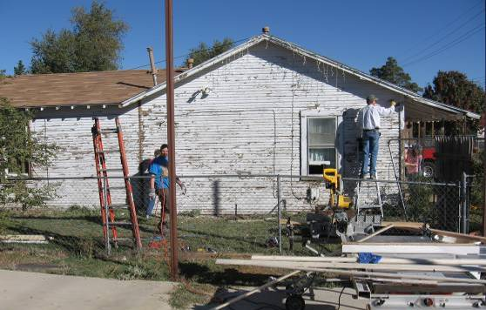
OCTOBER 2012

Families Served - 992

I love that God made us that way. And isn’t that just like Him? He asks us to bless others, and then surprises us with our own blessing through that obedience.

GREAT JOB WESTMINSTER!
---------------------------------------------
Winter is right around the corner, and with it comes requests for heat. Thanks to a donation of personal heaters from a LakeRidge family; we will have something to offer folks when repairing/replacing a heater is just too expensive!
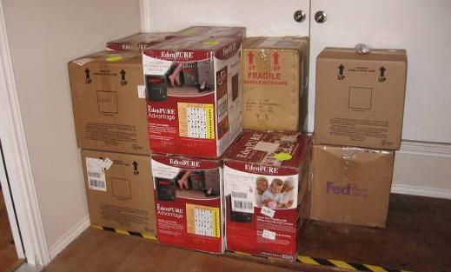
Please consider a donation to BYM this fall, as winter is one of our more expensive times of the year.

Board Members:

Jim Taylor (chrmn) Jackson Ashburn Lindy Fruge’ Glenn West

Darrel Goss

LAURIE FOSTER, Founder/Director
8205 Quincy Ave (806) 300-0184
Lubbock, TX 79424
Lfoster@backyardmission.org / www.backyardmission.org

2011-2012 Grants
Betenbough Homes. Monty Miller Living Legacy. LeGrande & Cassandra Northcutt Donor Advised Fund at East Texas Communities Foundation. Chester & Ada Ruth Green Charitable Endowment, Mrs. Fern Cone Endowment, Roy & Lela Furr Fund, C.R. & Virginia Hutcheson Charitable Fund, Hassel Endowment, Horizon Fund, Gladys Leftwich Endowment, W.B.Rushing & Mozelle Rushing Family Fund, H.D.Snell Endowment - all of the Lubbock Area Foundation, and Lubbock Area Foundation charitable funds.

