Backyard Mission Newsletter…do the Word.

Mission Statement:

1. Get people warm and dry by providing free home repairs, using volunteer labor and buying materials with donated money. Demonstrating the love of Christ!

2. Give Christians the opportunity to put their faith into action by loving and serving their neighbors.

3. Help other churches start a Backyard Mission program in their community.
____________________________________________

Westminster Presbyterian continues to “love their neighbors” in Lubbock through Backyard Mission.

Not all of our projects are this “extreme”, but what a difference a day can make!

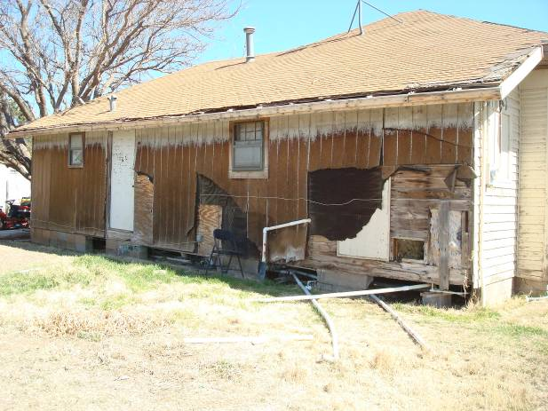

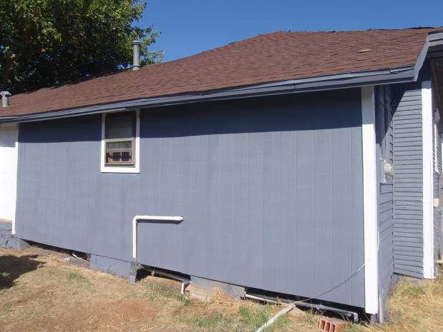
OCTOBER 2011

Families Served - 898

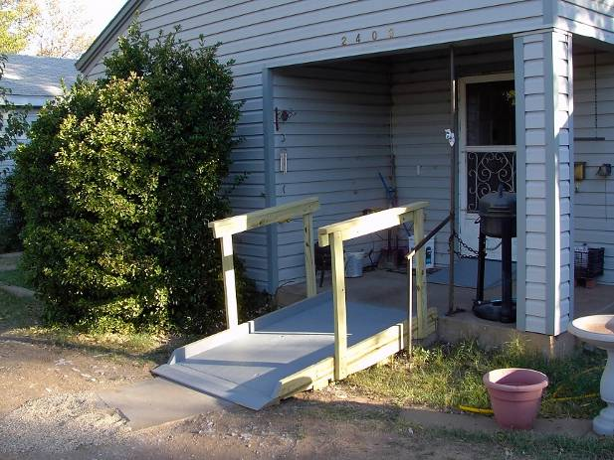

Backyard Mission was glad to partner with Caprock AMBUCS on this ramp. BYM purchased the materials and they built the ramp.

***Tammy, from Meals on Wheels, shared this… “A.D. (homeowner) called me and is so appreciative and grateful for the hard work you all put in on his ramp. He told me how well constructed it is, that there is texture on it, etc. He is very impressed.” ***

People really can make a difference in someone’s life in a day!

Board Members:

Jim Taylor (chrmn) Jackson Ashburn Lindy Fruge’ Glenn West

Darrel Goss

LAURIE FOSTER, Founder/Director
8205 Quincy Ave (806) 300-0184
Lubbock, TX 79424
Lfoster@backyardmission.org / www.backyardmission.org

2010-2011 Grants
Betenbough Homes. Monty Miller Living Legacy. LeGrande & Cassandra Northcutt Donor Advised Fund at East Texas Communities Foundation. Chester & Ada Ruth Green Charitable Endowment, W.B.Rushing & Mozelle Rushing Family Fund, H.D.Snell Endowment - all of the Lubbock Area Foundation, and Lubbock Area Foundation charitable funds.

