Backyard Mission Newsletter…do the Word.

Mission Statement:

1. Get people warm and dry by providing free home repairs, using volunteer labor and buying materials with donated money. Demonstrating the love of Christ!

2. Give Christians the opportunity to put their faith into action by loving and serving their neighbors.

3. Help other churches start a Backyard Mission program in their community.
____________________________________________

“We see people who have no ‘home building skills’, come and find they have ‘Kingdome Building Skills’.”

This is a quote from Matt Mitchell of Westminster Presbyterian Church. Westminster is one of our faithful church partners. They are an amazing group!

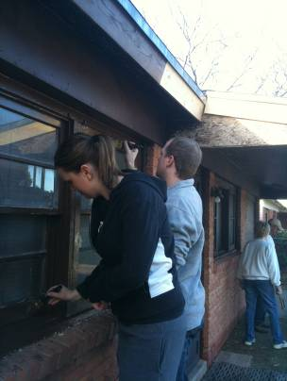
People from all walks of life, coming together to serve strangers, and each other.

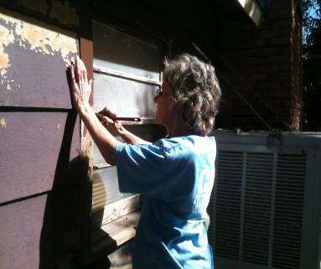
People within our church who don’t know each other, building new friendships.
“Every time we have a ‘Home Makeover Workday’, we get to see the church in action.”
OCTOBER 2010

Families Served - 830

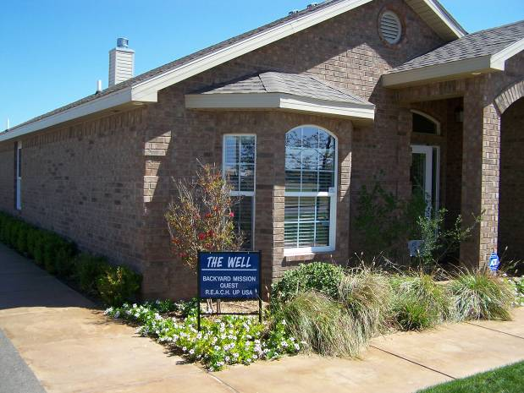

Blessing upon Blessing! Betenbough Companies have offered to give “The Well” to Backyard Mission. Their amazing heart, to use kingdom resources to serve as many as possible, drives this decision.
Because Backyard Mission is a 501c3, we can apply to be exempt from property taxes. This gives us additional funds that can be used to help someone. For us, that will translate into 3 or 4 more wall heaters we can install in elderly people’s homes this winter.
The Betenboughs hold God’s blessings loosely. They were not concerned about “ownership”, just creating the best situation to allow more of our resources to go towards helping those in need.
** A big thanks to Alamo Remodeling for providing
a dump truck for us!! **

Board Members:

Jim Taylor (chrmn) Jackson Ashburn Lindy Fruge’

Darrel Goss Glenn West

LAURIE FOSTER, Founder/Director
8205 Quincy Ave (806) 300-0184
Lubbock, TX 79424
Lfoster@backyardmission.org / www.backyardmission.org

2010 Grants
Betenbough Homes, Monty Miller Living Legacy, Chester and Ada Ruth Green Charitable Endowment of the Lubbock Area Foundation, and Lubbock Area Foundation charitable funds

