Backyard Mission
………repairing homes, restoring hope.

Mission Statement:

1. Get people warm and dry by providing free home repairs, using volunteer labor and buying materials with donated money. Demonstrating the love of Christ!

2. Give Christians/Service groups the opportunity to put their faith into action by loving and serving their neighbors.

3. Help other churches start a Backyard Mission program. ____________________________________________

A Remarkable Son

One of the things we see sometimes in this ministry; is adult children, taking advantage of their elderly parent. It is my honor to tell you about Eugene Patterson. Eugene came from Dallas to visit his mom this summer, and while here, did weeks of work on her home to get it warm and dry. Backyard Mission provided the materials.

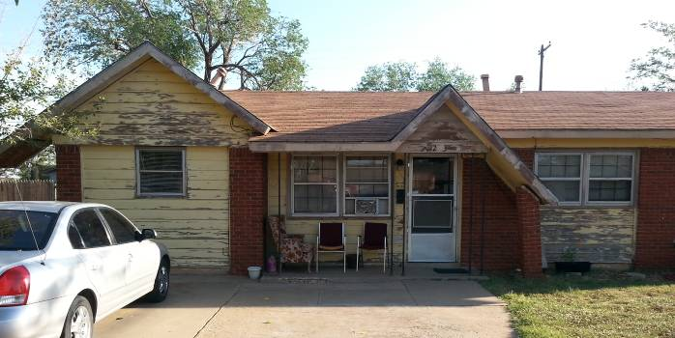

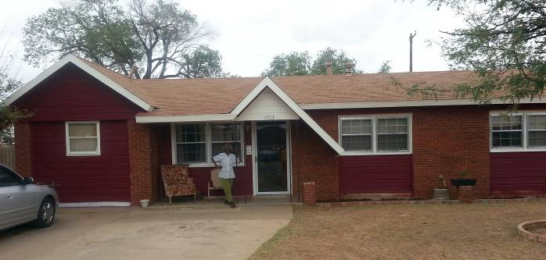

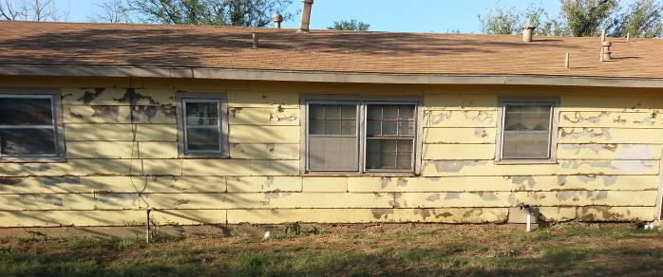
NOVEMBER 2013

Projects to date - 1094
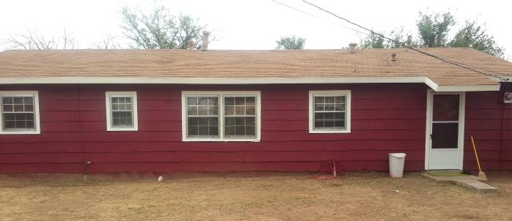

Repairs completed: siding repair, exterior paint, storm windows, and storm doors.


Exodus 20:12
“Honor your father and your mother, so that you may live long in the land the Lord your God is giving you.”

Well done Eugene! It was a privilege to work with you.

CONSIDER GIVING A DONATION IN HONOR/MEMORY OF SOMEONE FOR CHRISTMAS THIS YEAR!

Board Members:

Jim Taylor (chrmn) Jackson Ashburn Lindy Fruge’ Darrel Goss

Glenn West

LAURIE FOSTER, Founder/Director
8205 Quincy Ave (806) 300-0184
Lubbock, TX 79424
Lfoster@backyardmission.org / www.backyardmission.org

2012-2013 Grants
Betenbough Homes. Monty Miller Living Legacy. LeGrande & Cassandra Northcutt Donor Advised Fund at East Texas Communities Foundation, Chester & Ada Ruth Green Charitable Endowment, Mrs. Fern Cone Endowment, Roy & Lela Furr Fund, C.R. & Virginia Hutcheson Charitable Fund, Hassel Endowment, Horizon Fund and Gladys Leftwich Endowment, W.B. & Mozelle Rushing Family Endowment, and H.D. Snell Endowment, of Lubbock Area Foundation, and LAF charitable funds.

