Backyard Mission
.…repairing homes, restoring hope….

Mission Statement:

1. Get people warm and dry by providing free home repairs, using volunteer labor and buying materials with donated money. Demonstrating the love of Christ!

2. Give Christians/Service groups the opportunity to put their belief into action, by loving and serving their neighbors.

3. Help other churches start a Backyard Mission program. ________________________________________________________

2023 Backyard Mission
Service Report

Total Projects 1992 - 2023: 1734
Total Projects in 2023: 34

Repair type and # of homes that received that repair:
Water heaters 3
Siding/trim/paint 11
Plumbing repairs 9
Storm windows 12
A/C Repair/Window Unit 1
Doors 14
Miscellaneous Repairs 14
Heaters 7
TUB STEP 3

Volunteer groups:
BYM Dream Team Volunteers
First United Methodist - Lubbock

Professionals:
Dale Bolles Plumbing, Heating & Air
Texas Homeland Electric

Agency Partners:
APS / SPAG
Meals on Wheels
City of Lubbock
Home Health Agencies

(*Funds were low this year and we could not offer some of the assistance we have in the past.*)
March 2024

Projects to date – 1739

To address a need we have seen for a long time; this fall we began offering the CLEAN CUT TUB STEP.
We receive requests for bathroom modifications. We cannot do a complete tub to shower conversion. However, I came across a wonderful product called the CLEAN CUT TUB STEP. By cutting part of the tub out and installing this insert, it allows the homeowner to get into their existing tub/shower, without a total conversion. We are partnering with Adult Protective Services to provide these.
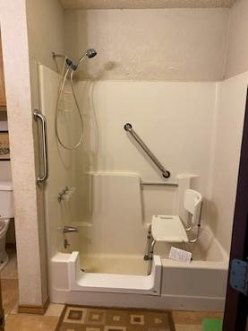
Our package includes the tub step, grab bars, shower wand, and shower seat. A huge shout out to our Dream Team who were willing to learn how to install these, along with all the other hard work they do to “love their neighbor”!

We appreciate and depend on your generous donations to continue this ministry. Consider giving a gift to Backyard Mission this spring.

--------------------------------------------
LAURIE FOSTER, Founder/Director
8205 Quincy Ave (806) 300-0184
Lubbock, TX 79424 (land line)
lfoster@backyardmission.org /www.backyardmission.org

