Backyard Mission
.…repairing homes, restoring hope….

Mission Statement:

1. Get people warm and dry by providing free home repairs, using volunteer labor and buying materials with donated money. Demonstrating the love of Christ!

2. Give Christians/Service groups the opportunity to put their belief into action, by loving and serving their neighbors.

3. Help other churches start a Backyard Mission program. ________________________________________________________

CREATIVE AND SURPRISING

The longer I follow the Lord, the more I discover about Him. His ways are unpredictable! This year, He has been both creative and surprising in His provision for Backyard Mission.

We were honored to be included in the will of Chester Green - a precious man whom I had known for many years of attending LakeRidge UMC together. The gift we received from his estate is allowing Backyard Mission to start 2016 in the best financial shape ever in 23 years.

We immediately called a Board meeting to begin praying about God’s desire and purpose for the gift. It wasn’t too long until He began to answer.

A local church, Experience Life, approached us with the goal of completing all our remaining 2014 and 2015 applications. 35+ projects!

I love that after 23 years He still surprises us! We are excited to see what God accomplishes through the gift of Chester Green, and the servant heart of Experience Life Church.

“……..more than we can ask or imagine.”

MARCH 2016

Projects to date – 1261

One of Experience Life’s “life groups” began working this past weekend. This group was led by Curry Blackwell!

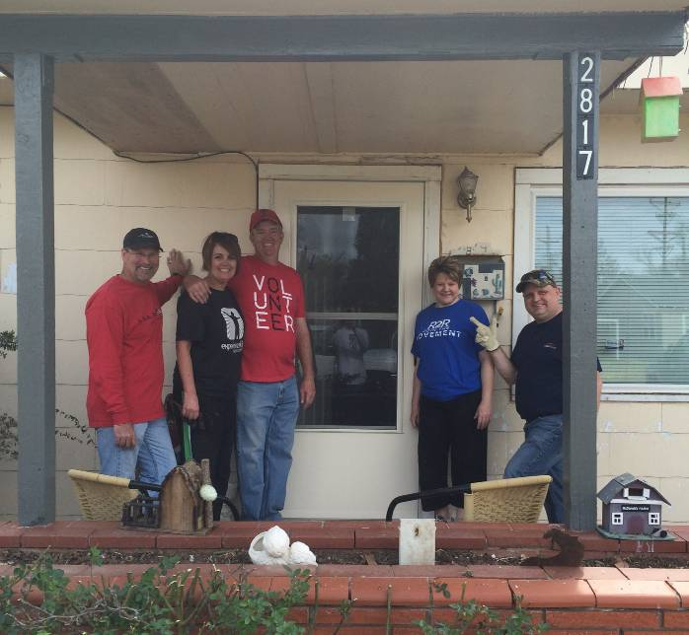

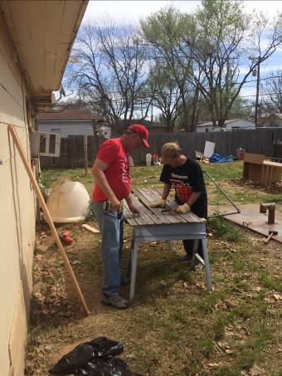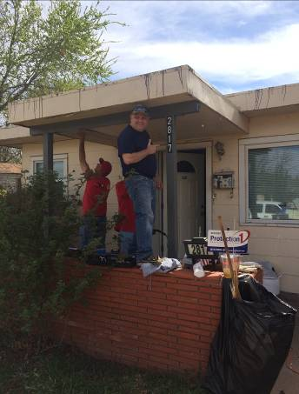

Board Members:

Jim Taylor (chrmn) Jackson Ashburn

Lindy Fruge’ Darrel Goss

Glenn West

LAURIE FOSTER, Founder/Director
8205 Quincy Ave (806) 300-0184
Lubbock, TX 79424
Lfoster@backyardmission.org / www.backyardmission.org

