Backyard Mission Newsletter…do the Word.

Mission Statement:

1. Get people warm and dry by providing free home repairs, using volunteer labor and buying materials with donated money. Demonstrating the love of Christ!

2. Give Christians the opportunity to put their faith into action by loving and serving their neighbors.

3. Help other churches start a Backyard Mission program in their community.
____________________________________________

LOCAL OR FOREIGN MISSIONS?

I am a local missionary. My heart is to serve the community where I live, and help the local church make an impact in its own “backyard”.

In every church, there is a typical question, “Local or foreign missions, which is more important?” The answer is BOTH. God does not care more about the man in Africa, than he does about your next door neighbor. As a matter of fact……….it’s ALL local to God. The world is His backyard, and everyone is His neighbor.

The church, His “body”, is made of many parts, and He calls each of us to “love our neighbor”. For some, that is across town, for others it is across the world. BOTH matter to God.

What lights up your heart? A specific people group, a certain region of the world, an injustice you feel called to do something about? Whoever, wherever, and whatever it is……go, and love your neighbor.
JUNE 2011

Families Served - 863

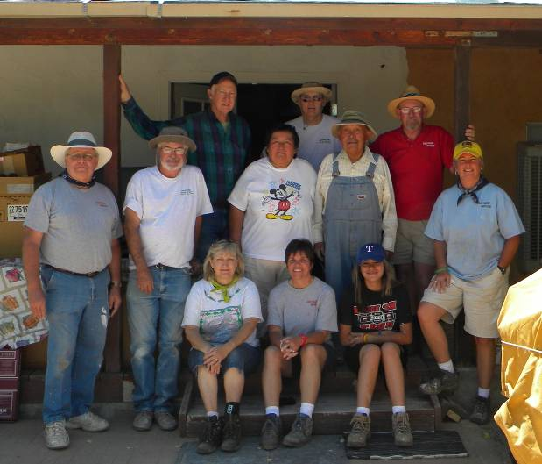
Our LakeRidge UMC Backyard Mission team; serving the Navajo Nation in Shiprock, NM this month.
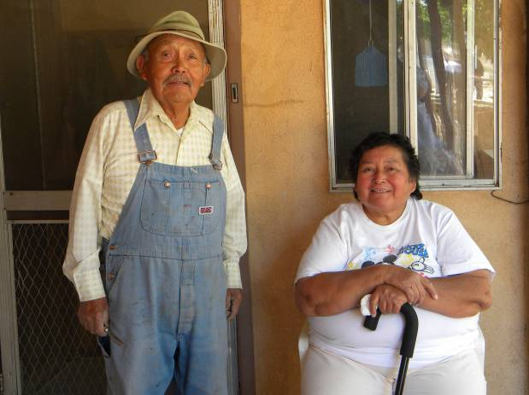
Our Navajo “neighbors” – Victor and Nancy.
I also love taking a trip each year, great fellowship with our team and the family we serve!

Board Members:

Jim Taylor (chrmn) Jackson Ashburn Lindy Fruge’

Darrel Goss Glenn West

LAURIE FOSTER, Founder/Director
8205 Quincy Ave (806) 300-0184
Lubbock, TX 79424
Lfoster@backyardmission.org / www.backyardmission.org

2010-2011 Grants
Betenbough Homes. Monty Miller Living Legacy. LeGrande & Cassandra Northcutt Donor Advised Fund at East Texas Communities Foundation. Chester & Ada Ruth Green Charitable Endowment, W.B.Rushing & Mozelle Rushing Family Fund, H.D.Snell Endowment - all of the Lubbock Area Foundation, and Lubbock Area Foundation charitable funds.

