Backyard Mission Newsletter…do the Word.

Mission Statement:

1. Get people warm and dry by providing free home repairs, using volunteer labor and buying materials with donated money. Demonstrating the love of Christ!

2. Give Christians the opportunity to put their faith into action by loving and serving their neighbors.

3. Help other churches start a Backyard Mission program in their community.
____________________________________________

GOOD NEWS from around the US!

I recently found out that two more churches in the US are now running Backyard Mission programs….a Baptist church in Rayville, LA; and a Methodist church in Enterprise, AL.

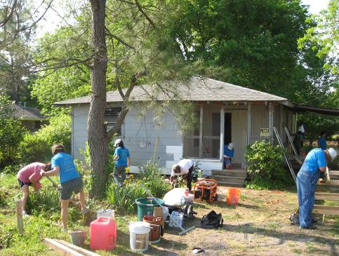

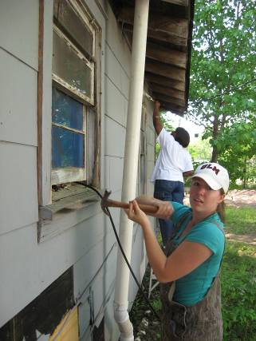
These are pictures of the Louisiana group at work. Their program is called “Signs of Life”. Looks familiar doesn’t it? Blessings to you all as you “love your neighbor!”

We get requests for our “how to” packets continuously, but we don’t always hear back from them. It was fun to learn about these two programs.
JUNE 2010

Families Served - 788

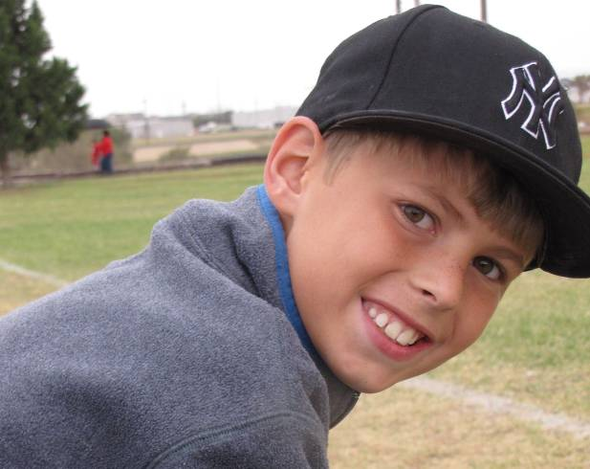

When I hear of a kid doing something special, out of the ordinary and unselfish, I love to share it. Blake Smallwood is one such kid.
This year for his 12th birthday, instead of having his friends bring presents for himself, he asked them to bring a cash donation which would go to a ministry to help others. Blake chose to give his birthday donations to Backyard Mission. We were so honored to receive this offering.
I am even more honored to know Blake and his family, and to see them stepping “outside the box” and making a difference in someone’s life.

Thank you for blessing us Blake, so that we may be a blessing to others.

** A big thanks to Alamo Remodeling for providing
a dump truck for us!! **

Board Members:

Jim Taylor (chrmn) Jackson Ashburn Lindy Fruge’

Darrel Goss Glenn West

LAURIE FOSTER, Founder/Director
8205 Quincy Ave (806) 300-0184
Lubbock, TX 79424
Lfoster@backyardmission.org / www.backyardmission.org

2010 Grants
Betenbough Homes

