Backyard Mission
.…repairing homes, restoring hope….

Mission Statement:

1. Get people warm and dry by providing free home repairs, using volunteer labor and buying materials with donated money. Demonstrating the love of Christ!

2. Give Christians/Service groups the opportunity to put their belief into action, by loving and serving their neighbors.

3. Help other churches start a Backyard Mission program. ________________________________________________________

2021 Backyard Mission Service Report

Total Projects 1992 - 2020: 1652
Total Projects in 2020: 44

Repair type and # of homes that received that repair:
Roofs 4
Water heaters 7
Siding/trim/paint 11
Plumbing repairs 17
Storm windows 13
A/C Repair/Window Unit 1
Doors 15
Miscellaneous Repairs 15
Heaters 8

Volunteer groups:
BYM Dream Team Volunteers
First United Methodist - Lubbock

Professionals:
Dale Bolles Plumbing, Heating & Air

Agency Partners:
APS / SPAG
Meals on Wheels
City of Lubbock
Home Health Agencies

*Covid has certainly affected our projects and volunteers the past couple of years. 2022 is looking more promising!
June 2022

Projects to date – 1677

I have to brag on my Dream Team. They get into some pretty rough projects, but this was a first.
Toilet had fallen through the floor. They rolled up their sleeves, donned their masks,
put Vicks under their noses, and got after it. I am blessed to work with the finest of men!

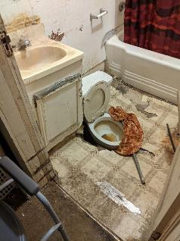

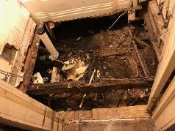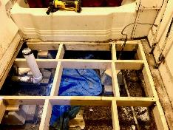

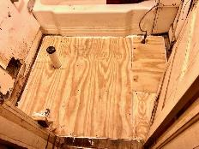
--------------------------------------------
LAURIE FOSTER, Founder/Director
8205 Quincy Ave (806) 300-0184
Lubbock, TX 79424 (land line)
Lfoster@backyardmission.org / www.backyardmission.org

