Backyard Mission Newsletter…do the Word.

Mission Statement:

1. Get people warm and dry by providing free home repairs, using volunteer labor and buying materials with donated money. Demonstrating the love of Christ!

2. Give Christians the opportunity to put their faith into action by loving and serving their neighbors.

3. Help other churches start a Backyard Mission program. ____________________________________________
Experiences shared by an E-Life volunteer group:

“Three Experience Life small groups teamed up to work on the home. Our hearts were immediately captured by the exuberant little girls and their elderly grandparents caring for them. The work went more smoothly and quickly than any of us had imagined. And we were all grateful for that!
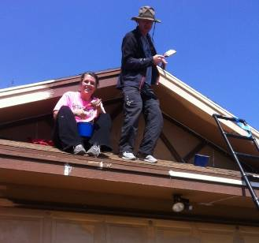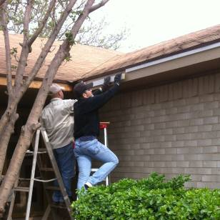
But there were a few unexpected moments that really stood out. First, how blessed we felt when the owner said that it looked like a new house to her.
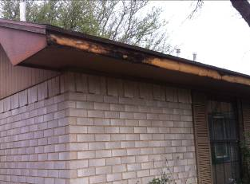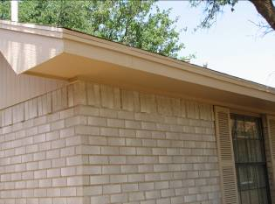

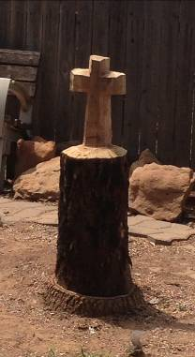
Next, when the team responsible for taking down the huge dead tree in the backyard left a beautiful carved cross in its place.

JUNE 2013

Families Served - 1052

Then, how the older and younger groups, having not met before that day, built community. ("Thank you for helping us," said the older. "Thank you for letting us," said the younger.).
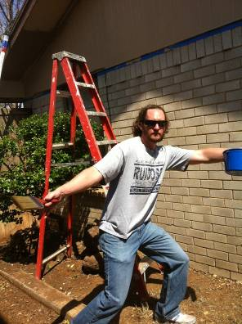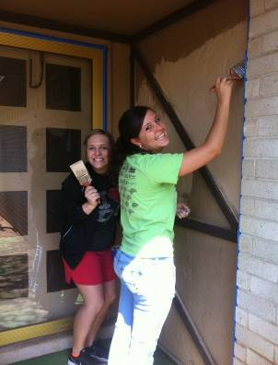
Finally, the team and the family holding hands in prayer. 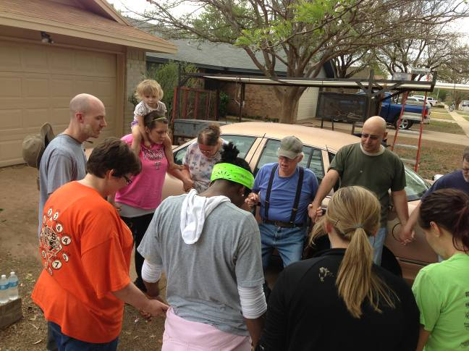
Our Father God is always building, always making things new, always drawing His children closer into communion with Him and each other....always surprising with His extravagant grace.”

God is always up to more than we can imagine or expect. He takes our simple acts of obedience and multiplies those into blessing upon blessing!

Board Members:

Jim Taylor (chrmn) Jackson Ashburn Lindy Fruge’ Darrel Goss Glenn West
LAURIE FOSTER, Founder/Director
8205 Quincy Ave (806) 300-0184
Lubbock, TX 79424
Lfoster@backyardmission.org / www.backyardmission.org

