Backyard Mission
.…repairing homes, restoring hope….

Mission Statement:

1. Get people warm and dry by providing free home repairs, using volunteer labor and buying materials with donated money. Demonstrating the love of Christ!

2. Give Christians/Service groups the opportunity to put their belief into action, by loving and serving their neighbors.

3. Help other churches start a Backyard Mission program. ________________________________________________________

THIS THING CALLED MISSION WORK

A person cannot stay in mission work long without asking some hard questions and coming to the conclusion that God is God and His only objective is ”to draw all people unto Him” because of His great love for them.

We humans don’t think that way naturally, but with the power of the Holy Spirit, we can get there. But “loving our neighbor” can be messy and hard, and it doesn’t always feel “warm and fuzzy”.

I usually genuinely like the folks we help. But, I remember getting in my truck one day, after conducting a home visit, and saying out loud, “Lord, I just did not like those people very much.” Immediately I heard God say, “I didn’t ask you to like them. I asked you to love them, and to tell them that I love them. Do you think you can do that?” With head bowed, I whispered, “Yes sir.”

Christ died for me because He loved me. Not because I deserved it, was thankful, was likable, etc. And He asks us to extend that same love to those around us. Not because they deserve it, are thankful, are likeable, but because He loves them.

So, on days when this thing called mission work is hard, I remember that it has nothing to do with how I feel. It has everything to do with His love for every single one of us. So I tell them, “You have a God who sees you, knows you, loves you, and has come to meet your need.”
JULY 2016

Projects to date – 1311

Experience Life Church has been hard at it this spring/summer…….adopting 33 of our homes!

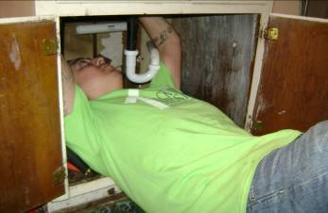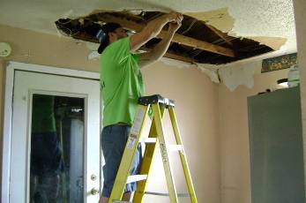

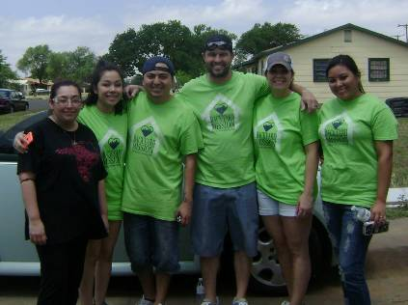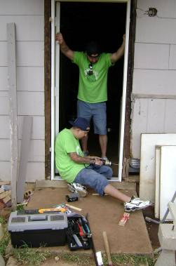

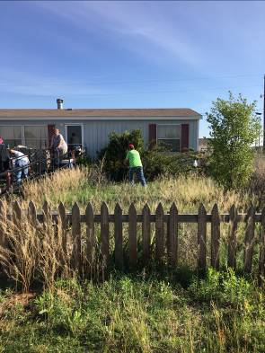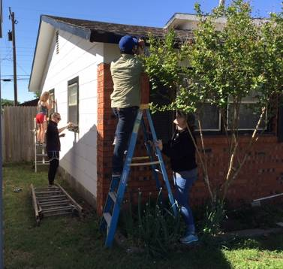

Doing the sometimes hard and messy work of “loving their neighbor!” Thank you E-life!

Board Members:

Jim Taylor (chrmn) Jackson Ashburn

Lindy Fruge’ Darrel Goss

Glenn West

LAURIE FOSTER, Founder/Director
8205 Quincy Ave (806) 300-0184
Lubbock, TX 79424 (land line)
Lfoster@backyardmission.org / www.backyardmission.org

