Backyard Mission
.…repairing homes, restoring hope….

Mission Statement:

1. Get people warm and dry by providing free home repairs, using volunteer labor and buying materials with donated money. Demonstrating the love of Christ!

2. Give Christians/Service groups the opportunity to put their belief into action, by loving and serving their neighbors.

3. Help other churches start a Backyard Mission program. ________________________________________________________

2018 PROJECT REPORT
Total Projects 1992 - 2018: 1505
Total Projects in 2018: 53

Repair type and # of homes that received that repair:
Roofs 5
Siding/ext. paint 15
Storm windows 16
Doors 17
Heaters 8
Water heaters 10
Plumbing repairs 16
A/C Repair/Window Unit 5
Miscellaneous Repairs 19

Volunteer groups:
BYM Dream Team Volunteers
BYM Families/Homeowners
First United Methodist Church
Wesley Foundation

Professionals:
Dale Bolles Plumbing, Heating & Air
D-B Roofing
Kevin Tosi Roofing
Phil Kerr Plumbing

Agency Partners:
APS / SPAG City of Lubbock
Meals on Wheels Home Health Agencies

This was a different year for us. We had fewer volunteer groups and our projects were more extensive and took longer to complete.
We are looking forward to 2019!
January 2019

Projects to date – 1510

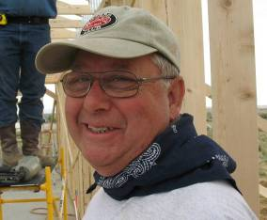
We said “good-bye” to our friend Jim Taylor this fall. He joined Backyard Mission the first year we began, and was a faithful partner in ministry for 26 years. You cannot replace a Jim Taylor. He was one of a kind! No doubt he heard the Lord say, “Well done good and faithful servant.”

A month later we lost David True, one of our faithful Dream Team volunteers. I have no doubt he and Jim are doing a little fly fishing together. Those two did know how to have a good time together!
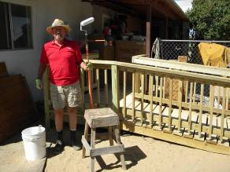
WE LOVE AND MISS Y’ALL!
--------------------------------------------
LAURIE FOSTER, Founder/Director
8205 Quincy Ave (806) 300-0184
Lubbock, TX 79424 (land line)
Lfoster@backyardmission.org / www.backyardmission.org

