Backyard Mission
.…repairing homes, restoring hope….

Mission Statement:

1. Get people warm and dry by providing free home repairs, using volunteer labor and buying materials with donated money. Demonstrating the love of Christ!

2. Give Christians/Service groups the opportunity to put their belief into action, by loving and serving their neighbors.

3. Help other churches start a Backyard Mission program. ________________________________________________________

2017 Backyard Mission
Service Report

Total Projects 1992 - 2017: 1452
Total Projects in 2017: 93

93 projects were completed this year, and we had the pleasure of working with several different volunteer groups and professionals.

Repair type and # of homes that received that repair:
Roofs 14
Water heaters 16
Siding/ext. paint 15
Plumbing repairs 33
Storm windows 12
Heaters 11
Doors 19
A/C Repair/Window Unit 7
Miscellaneous Repairs 30

Volunteer groups:
BYM Dream Team Volunteers
BYM Families/Homeowners
Aldersgate UMC
Betenbough Homes
Experience Life Church
First United Methodist Church
John Soto – Tile
LakeRidge UMC – youth
Living Stone Church
Mickey Allen Group
RHO - TTU
St. Luke’s UMC
JANUARY 2018

Projects to date – 1452

Professionals:
ABCO Glass
Dale Bolles Plumbing, Heating & Air
Daryl Hawkins - Electrical
Jarrell Rowell - Plumbing
Kevin Tosi Roofing
Overhead Door
Roto-Rooter
Spartan Plumbing

Agency Partners:
APS / SPAG
Meals on Wheels
City of Lubbock
Home Health Agencies
--------------------------------------------
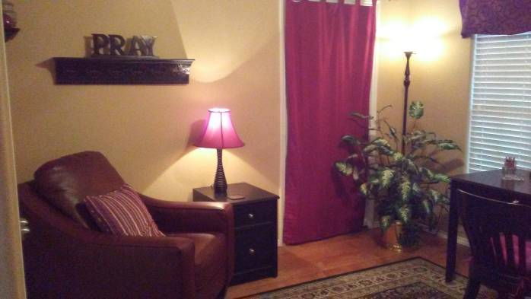

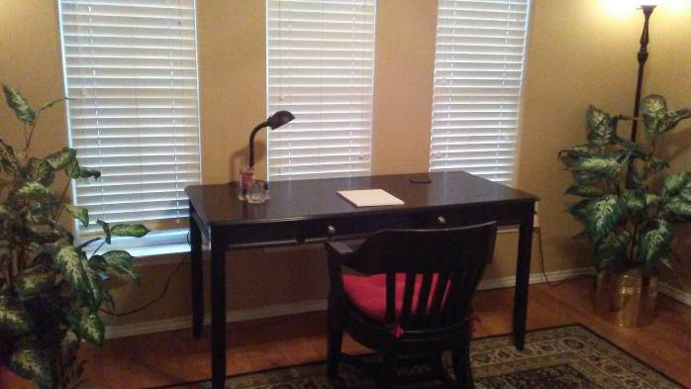
Need a place to get alone to pray, study, write? We have a prayer room here we would love to share with you!
Call Laurie to schedule! 806-549-1414
--------------------------------------------
Board Members:

Jim Taylor (chrmn) . Jackson Ashburn

Lindy Fruge’ Darrel Goss

LAURIE FOSTER, Founder/Director
8205 Quincy Ave (806) 300-0184
Lubbock, TX 79424 (land line)
Lfoster@backyardmission.org / www.backyardmission.org

