Backyard Mission
.…repairing homes, restoring hope….

Mission Statement:

1. Get people warm and dry by providing free home repairs, using volunteer labor and buying materials with donated money. Demonstrating the love of Christ!

2. Give Christians/Service groups the opportunity to put their belief into action, by loving and serving their neighbors.

3. Help other churches start a Backyard Mission program. ________________________________________________________

2014 Backyard Mission Service Report

Total Projects 1992 - 2014: 1176
Total Projects in 2014: 67

67 families received help from Backyard Mission this past year, and we had the pleasure of working with several different volunteer groups.

Repairs and # of Homes that received that repair:
Roofs 9
Siding/ext. paint 13
Storm windows 16
Doors 17
Heaters 14
Water heaters 11
Plumbing repairs 11
Misc. repairs or A/C 15

Volunteer groups:
BYM Dream Team Volunteers
BYM families/homeowners
Aldersgate UMC Belville Baptist Youth
Experience Life Indiana Ave Baptist
Meals on Wheels Monterey COC
Salado UMC Youth UMARMY
Wolfforth UMC Youth Robinson Family
Westminster Presbyterian LakeRidge UMC

Professionals:
Dale Bolles Grande Plumbing

Agency Partners:
APS / SPAG / CPS Meals on Wheels
City of Lubbock Home Health Agncs
February 2015

Projects to date – 1182

“I don’t really like to give to operating costs.”

Anyone ever felt like that? I’ve even said that same thing myself. Just feels better to buy some paint, or pay for a heater doesn’t it?

Look at the 2014 service report and consider this………if there was not an office, with a person in it, and no electricity, phone, or internet………none of those people could have experienced the love of Christ through Backyard Mission.

Our perspective…in 2014, Maria went from bathing
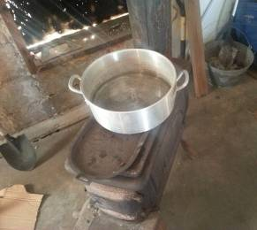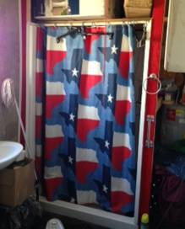
like this to this

YOUR GIFT DID THAT!
Whether it paid for the internet so the Adult Protective Services caseworker could email her application to us, or paid the plumber.

Truth is; all these things have to be in place for people to get help. We value every gift you give. So, let me encourage you……if you help us have a phone line; people who need help can call us, and volunteers who want to help someone can talk to us, and donors can find out how to give, etc. You get the picture. ☺

What is also true is that any organization you give to: charity, church, non-profit; should be transparent with finances. See what your gift is doing to help folks!

CONSIDER GIVING A DONATION IN HONOR/MEMORY OF SOMEONE THIS YEAR!

Board Members:

Jim Taylor (chrmn) Jackson Ashburn

Lindy Fruge’ Darrel Goss

LAURIE FOSTER, Founder/Director
8205 Quincy Ave (806) 300-0184
Lubbock, TX 79424
Lfoster@backyardmission.org / www.backyardmission.org

