Backyard Mission Newsletter…do the Word.

Mission Statement:

1. Get people warm and dry by providing free home repairs, using volunteer labor and buying materials with donated money. Demonstrating the love of Christ!

2. Give Christians the opportunity to put their faith into action by loving and serving their neighbors.

3. Help other churches start a Backyard Mission program in their community.
____________________________________________

2009 Service Report

89 families received help from Backyard Mission this past year, and we had the pleasure of working with several different volunteer groups.

Homes and repairs:
Roofs 14
Siding/ext. paint 13
Storm windows 24
Doors 22
Heat 9
Water heaters 22
Plumbing repairs 14
Misc. or A/C 21

Volunteer groups:
BYM Dream Team LakeRidge UMC
Oakwood Methodist Experience Life
Adult Protective Services The Springs
Second Baptist Texas Ramps
Lubbock Changers Wolfforth UMC
Oakwood Baptist BYM families
Cooper High School Allen, TX group
Frenship High School
Westminster Presbyterian

Plumbing by:
Dale Bolles and Jarrell Rowell

**Your gifts of time and money make this possible.**
FEBRUARY 2010

Families Served - 757

God continues to bless our new office. Melinda Paxton, owner of Merry Maids, has donated cleaning services to us! Woo-hoo! We are shiny and clean!

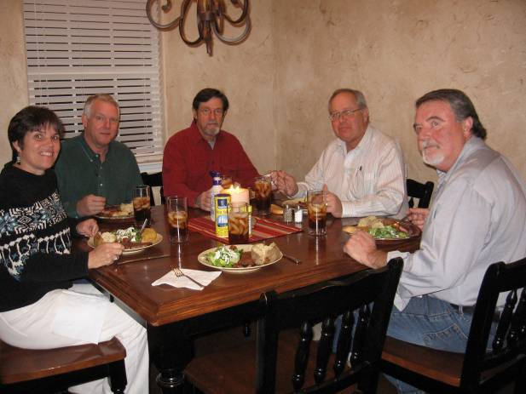
BYM Board Members - our first meeting at The Well in 2010. From left to right: Lindy Fruge’, Glenn West, Jackson Ashburn, Jim Taylor (chairman), and Darrel Goss. These folks are a tremendous blessing to me and keep me on track.
_____________________________
Jim and I got to speak in Floydada, Texas this month at FUMC. They are raring to go with their own Backyard Mission program! We love helping people start new programs. They already have a beautiful, fully stocked tool trailer.

** A big thanks to Alamo Remodeling for providing
a dump truck for us!! **

Board Members:

Jim Taylor (chrmn) Jackson Ashburn Lindy Fruge’

Darrel Goss Sheri Haynes Glenn West

LAURIE FOSTER, Founder/Director
8205 Quincy Ave (806) 300-0184
Lubbock, TX 79424
Lfoster@backyardmission.org / www.backyardmission.org

