Backyard Mission
.…repairing homes, restoring hope….

Mission Statement:

1. Get people warm and dry by providing free home repairs, using volunteer labor and buying materials with donated money. Demonstrating the love of Christ!

2. Give Christians/Service groups the opportunity to put their belief into action, by loving and serving their neighbors.

3. Help other churches start a Backyard Mission program. ________________________________________________________

We don’t always hear about the impact our witness has on the people we serve, but this time we did! Here is the “rest of the story”!

Gloria

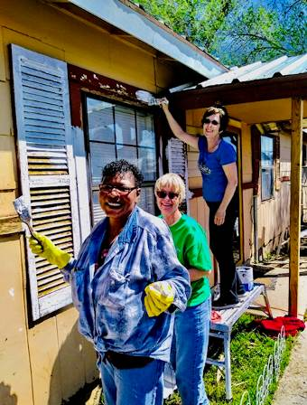

December 2019

Projects to date – 1552

This is from Frank & Kathy Phillips, who lead the Helping Hands ministry at FUMC. Our Dream Team and FUMC had worked on Gloria’s house, making major repairs off and on over a 6 month period.

In November of 2019 we received a text that Gloria was looking for us at church (FUMC). We attended church with her. During the service our church was asking for volunteers to work at our Community Thanksgiving Dinner. Gloria told us that she wanted to help. She said Backyard Mission and Helping Hands had done so much for her, she wanted to give back. Gloria did in fact come and help. She worked four hours helping to feed the hungry in downtown Lubbock!

On Thanksgiving Day, my phone rang, and it was Gloria. She told me that in December of 2018 she felt angry, and did not have any gratitude in her life. She told me that Backyard Mission and Helping Hands had given her joy in her life, and she was now looking for ways to help others.

--------------------------------------------
LAURIE FOSTER, Founder/Director
8205 Quincy Ave (806) 300-0184
Lubbock, TX 79424 (land line)
Lfoster@backyardmission.org / www.backyardmission.org

