Backyard Mission Newsletter…do the Word.

Mission Statement:

1. Get people warm and dry by providing free home repairs, using volunteer labor and buying materials with donated money. Demonstrating the love of Christ!

2. Give Christians the opportunity to put their faith into action by loving and serving their neighbors.

3. Help other churches start a Backyard Mission program in ____________________________________________

….if we can, when we can, as often as we can.

By the end of 2012, Backyard Mission will have helped over 90, elderly, low-income, homeowners this year. That number reflects a wide variety of assistance, provided in a wide variety of ways.

It can be as small as installing an A/C window unit, or as big as a total roof replacement.
It can be something done by the BYM Dream Team volunteers, paid professionals, the family themselves, local church or business group, out of town youth, or partnering with a local agency. It’s always different.

People ask……..
How many projects will you do this year? I don’t know.
Where will the donations come from? I don’t know.
Who will volunteer? I don’t know.

I don’t know, because God does not tell me ahead of time. I sure would like it if He did, but that’s just not how He works with us.

“But you have to have a plan”, people say. We do! We show up each day, and help people…if we can, when we can, as often as we can.

God is much better at running this ministry than I ever could be! I just try to hang on!
DECEMBER 2012

Families Served - 1009

A note from educator, Mrs. Hayes: Trinity Christian School has a heart for missions, and each elementary class is allowed to select a specific mission organization to support. This fall I felt God was leading us in the direction of Backyard Mission. Selecting a local organization for her 5th grade homeroom students has given them a great enthusiasm, not only to support their adopted mission group with prayers but also in more hands on ways.
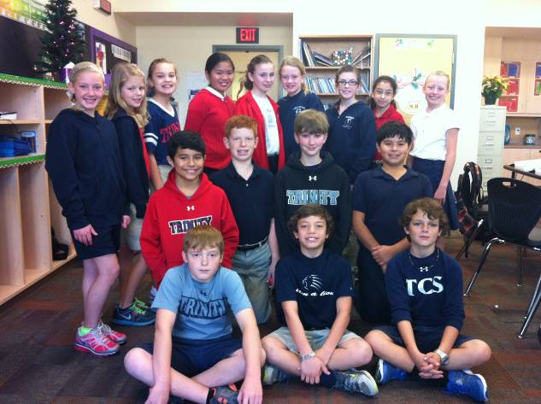
The students will be creating encouragement cards, working to collect simple supplies, delivering space heaters, helping to raise money and awareness about the work of Backyard Mission, and of course praying daily for God’s guidance and protection for all of those who are a part of this vital ministry. Already the students have been blessed to have a special visit from the Backyard Mission director, Laurie Foster, who shared the true heart of the ministry and won the respect and admiration of 16 students who are passionate about being a part of God’s kingdom work here in Lubbock.

Board Members:

Jim Taylor (chrmn) Jackson Ashburn Lindy Fruge’ Darrel Goss Glenn West

LAURIE FOSTER, Founder/Director
8205 Quincy Ave (806) 300-0184
Lubbock, TX 79424
Lfoster@backyardmission.org / www.backyardmission.org

2012-2013 Grants
Betenbough Homes. Monty Miller Living Legacy. LeGrande & Cassandra Northcutt Donor Advised Fund at East Texas Communities Foundation, Chester & Ada Ruth Green Charitable Endowment, Mrs. Fern Cone Endowment, Roy & Lela Furr Fund, C.R. & Virginia Hutcheson Charitable Fund, Hassel Endowment, Horizon Fund and Gladys Leftwich Endowment, W.B. & Mozelle Rushing Family Endowment, and H.D. Snell Endowment, of Lubbock Area Foundation, and LAF charitable funds.

