Backyard Mission Newsletter…do the Word.

Mission Statement:

1. Get people warm and dry by providing free home repairs, using volunteer labor and buying materials with donated money. Demonstrating the love of Christ!

2. Give Christians the opportunity to put their faith into action by loving and serving their neighbors.

3. Help other churches start a Backyard Mission program in their community.
____________________________________________
First Annual Backyard Mission Volunteer Appreciation
Chili Lunch!
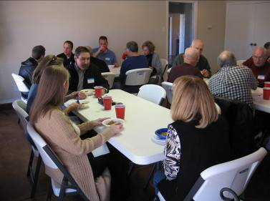
We had a great end of the year celebration for Backyard Mission and the various groups that help make it run.

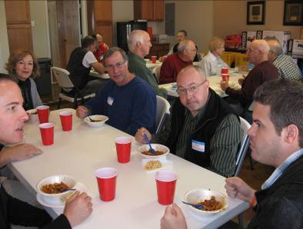
The Betenbough Company, our wonderful tool donors, Dream Team volunteers, and Lubbock Church Partners.

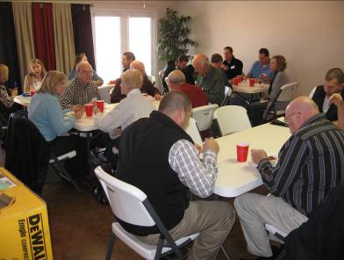
The BYM Prayer Team, LakeRidge UMC Mission Committee, and my faithful BYM Board Members.

2010 Grants
Betenbough Homes. Monty Miller Living Legacy. LeGrande & Cassandra Northcutt Donor Advised Fund at East Texas Communities Foundation. Chester & Ada Ruth Green Charitable Endowment, W.B.Rushing & Mozelle Rushing Family Fund, H.D.Snell Endowment - all of the Lubbock Area Foundation, and Lubbock Area Foundation charitable funds.
DECEMBER 2010

Families Served - 838

THEN THE FUN BEGAN!
A couple from LakeRidge UMC donated new power tools to BYM! After our chili lunch folks stayed around to help get these tools ready to use. They had to be unboxed, assembled, tried out, and ready to load in the trailer.
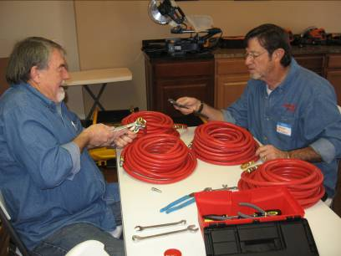

Goose and Jackson put fittings on the air hoses.
Kerry unpacks one of our two new air compress - ors.
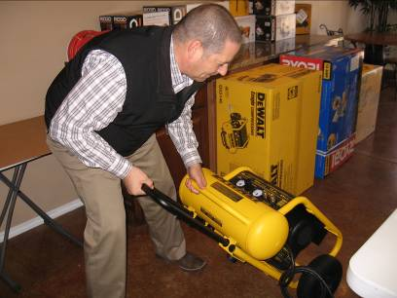
Mike, Jane, and Jackson assemble the sliding compound miter saw.
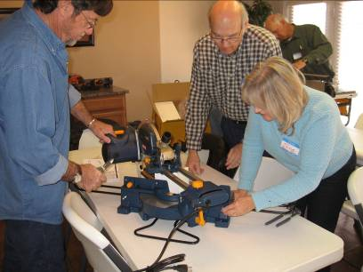

We also want to give a shout out and say “THANKS” to those generous folks who help keep our facility in great shape. AMAZING!

24-7 Security / Paula & Keith Weddle, owners
Installed and monitor our security system

Merry Maids / Melinda Paxton, owner
Monthly cleaning services

The Betenbough Company
Lawn service

