Backyard Mission Newsletter…do the Word.

Mission Statement:

1. Get people warm and dry by providing free home repairs, using volunteer labor and buying materials with donated money. Demonstrating the love of Christ!

2. Give Christians the opportunity to put their faith into action by loving and serving their neighbors.

3. Help other churches start a Backyard Mission program in their community.
____________________________________________
“Oh, the weather outside is frightful…”

It was the first really cold night of 2009. I turned up the heater, made a fire, and snuggled under a blanket on the couch. I silently thanked God that I was warm and safe in my home, and asked Him to comfort those who were not – remembering the applications sitting on my desk, people waiting for help.

I glanced around the room and smiled at all my animals, curled up in their favorite spots, also warm and safe – each a rescue story.

What is it inside us that compels us to make life better for other living beings – human and animal? What calls to our heart to make a difference when we can? To rescue those who cannot rescue themselves.

I believe it is love – God’s Holy Spirit that lives in our hearts. It is the same love that compelled Him to send His son to rescue us, to make life better for us.

This Christmas, may you accept God’s love and allow Him to rescue you, and in turn, compel you to make life better for someone else.
DECEMBER 2009

Families Served - 747

We love our new office – The Well. It has provided office space, a place for fellowship, bible studies, staff meetings, and volunteer lunches. What I love most is the fact that people say they can feel the spirit of God when they are here. Perfect.

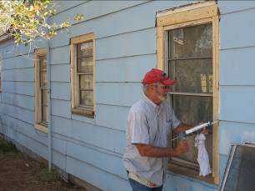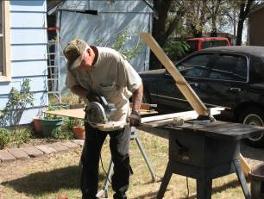

Our DREAM TEAM has been hard at work conducting home visits and making repairs. Amazing folks!

This week we provided a water heater, new supply lines and fixtures to an elderly couple, who had not had hot water in over 20 years.

Please, make a donation to Backyard Mission this Christmas. You may give directly to Backyard Mission, or continue to give through LakeRidge UMC.

** A big thanks to Alamo Remodeling for providing a dump truck for us!! **

Board Members:

Jim Taylor (chrmn) Jackson Ashburn Lindy Fruge’

Darrel Goss Sheri Haynes Glenn West

(Welcome new board members: Darrel and Jackson. Laren and Mary Kay, thank you for serving faithfully.)

LAURIE FOSTER, Founder/Director
8205 Quincy Ave (806) 300-0184
Lubbock, TX 79424
Lfoster@backyardmission.org / www.backyardmission.org

2008 / 2009 Grants
Betenbough Companies, Lubbock Area Foundation – unrestricted funds and Chester & Ada Ruth Green Endowment, South Plains Association of Governments, East Texas Foundation – LeGrand & Cassandra Northcutt, South Plains Foundation

