Backyard Mission
.…repairing homes, restoring hope….

Mission Statement:

1. Get people warm and dry by providing free home repairs, using volunteer labor and buying materials with donated money. Demonstrating the love of Christ!

2. Give Christians/Service groups the opportunity to put their belief into action, by loving and serving their neighbors.

3. Help other churches start a Backyard Mission program. ________________________________________________________

“They can cook!”

Once in a while a family is able to do something special for our volunteers to say “thank you”. Over the years we have had homeowners give us coffee and donuts, sandwiches and Gatorade, popsicles, and my favorite…homemade tamales!

The past couple of months our volunteers have really been blessed! One of our families grilled hamburgers one day; another day - sausage and tortillas, and a third day - made burritos! At another house the woman fixed spaghetti! I am afraid my guys are getting spoiled! (Of course, they deserve it!)

It is always fun to get that
unexpected blessing!

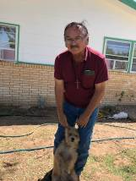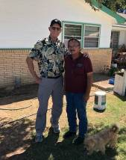
The “grill master and his mascot!”
(The pup is the mascot, not Tom)
August 2019

Projects to date – 1540

GO FIRST METHODIST!
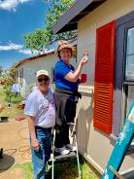

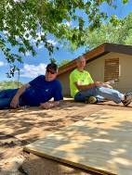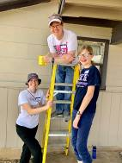

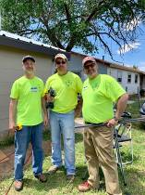
These guys are so great. A few of them peeled off their house and went a few blocks over to work with St. Luke’s UMC who had also adopted one of our houses! You gotta love the body working together!
--------------------------------------------
LAURIE FOSTER, Founder/Director
8205 Quincy Ave (806) 300-0184
Lubbock, TX 79424 (land line)
Lfoster@backyardmission.org / www.backyardmission.org

