Backyard Mission
.…repairing homes, restoring hope….

Mission Statement:

1. Get people warm and dry by providing free home repairs, using volunteer labor and buying materials with donated money. Demonstrating the love of Christ!

2. Give Christians/Service groups the opportunity to put their belief into action, by loving and serving their neighbors.

3. Help other churches start a Backyard Mission program. ________________________________________________________

“PERSPECTIVE”

Last spring I bought a small, used camper, and entered the unknown world of camping. And believe me, there is a whole world out there!

This little camper has everything one could ever need, but as I walked through “Camping World” last weekend, I saw so many things that I did not have, and didn’t even know they made for campers! What in the world!

“Perspective” is a powerful thing. It can work for us or against us. Most of us look in one direction…..towards people who have MORE. That can be a crippling perspective. If we never look the other direction and see the masses that have LESS, discontentment and resentment can begin to grow.

Daily, I have conversations with people who don’t have the basic necessities. I am greatly aware of all the blessings in my life.
I have hot water, my toilet flushes, my roof doesn’t leak, my doors and windows keep the weather out, etc.

If you find yourself feeling discontent or resentful, turn around and look in a different direction. Maybe a new “perspective” would ease your heart and mind. And if you really want to experience joy; volunteer, or give something away to someone who has LESS.
August 2018

Projects to date – 1488

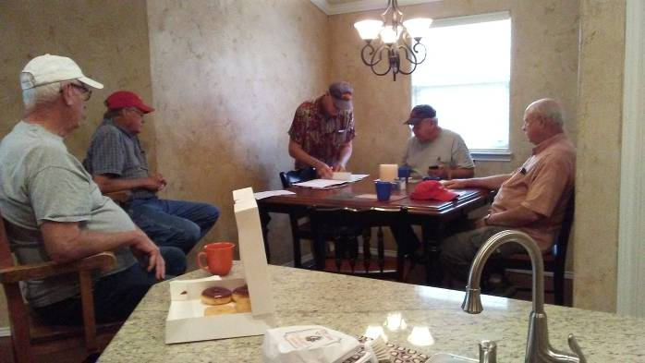

This is the scene at our office every Tuesday morning. A handful of men meet for coffee and donuts, then go work on our houses.

They are lovingly called “The
Dream Team”!

I say it often; I am blessed to work with some of the finest men in the world. Their faith is not something they do on Sundays, or once a year on a trip. It is a way of life they live out every day.

They “get it”.

God blesses so many people through these guys, but if you asked them, they would say they are the ones that get the blessing.
--------------------------------------------

Board Members:

Jim Taylor (chrmn) Jackson Ashburn

Lindy Fruge’ Darrel Goss

LAURIE FOSTER, Founder/Director
8205 Quincy Ave (806) 300-0184
Lubbock, TX 79424 (land line)
Lfoster@backyardmission.org / www.backyardmission.org

