Backyard Mission
.…repairing homes, restoring hope….

Mission Statement:

1. Get people warm and dry by providing free home repairs, using volunteer labor and buying materials with donated money. Demonstrating the love of Christ!

2. Give Christians/Service groups the opportunity to put their belief into action, by loving and serving their neighbors.

3. Help other churches start a Backyard Mission program. ________________________________________________________

SUMMER 2014

We were blessed this summer to have volunteer youth teams come out and work on several of our homes!
BELVILLE FBC
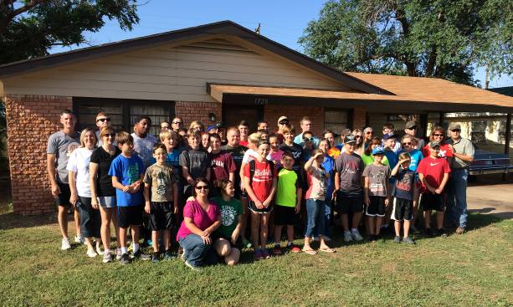

UMARMY
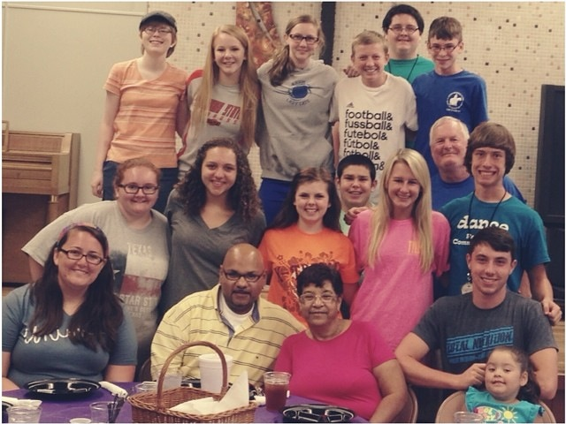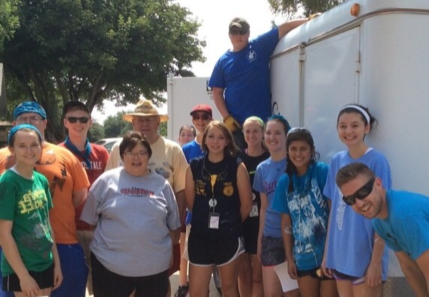

SALADO UMC
Thank you for loving your neighbors!

2013-2014 Grants
Betenbough Homes. Monty Miller Living Legacy. LeGrande & Cassandra Northcutt Donor Advised Fund at East Texas Communities Foundation, Chester & Ada Ruth Green Charitable Endowment, Mrs. Fern Cone Endowment, Roy & Lela Furr Fund, C.R. & Virginia Hutcheson Charitable Fund, Hassel Endowment, Horizon Fund and Gladys Leftwich Endowment, W.B. & Mozelle Rushing Family Endowment, and H.D. Snell Endowment, of Lubbock Area Foundation, and LAF charitable funds.
August 2014

Projects to date - 1148

THANK YOU E-LIFE!

We were grateful to be a part of Experience Life’s summer mission outreach – PROJECT ONE. In August the church had teams all over the city volunteering with various local mission organizations. They adopted two of our homes and did a great job “loving their neighbor” right here in Lubbock!
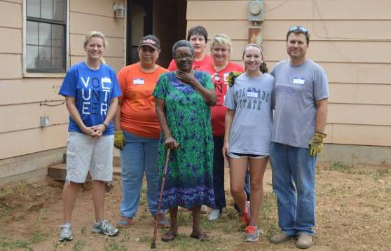

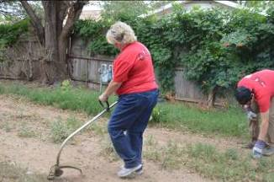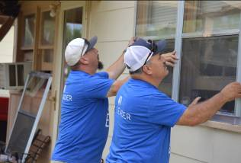

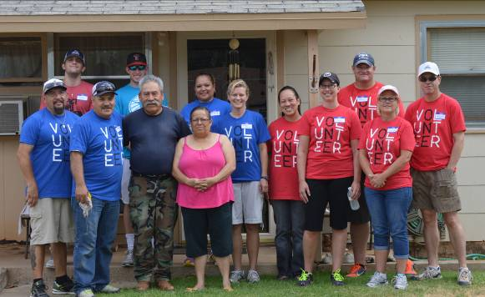

CONSIDER GIVING A DONATION IN HONOR/MEMORY OF SOMEONE THIS YEAR!

Board Members:

Jim Taylor (chrmn) Jackson Ashburn

Lindy Fruge’ Darrel Goss

Glenn West

LAURIE FOSTER, Founder/Director
8205 Quincy Ave (806) 300-0184
Lubbock, TX 79424
Lfoster@backyardmission.org / www.backyardmission.org

