Backyard Mission Newsletter…do the Word.

Mission Statement:

1. Get people warm and dry by providing free home repairs, using volunteer labor and buying materials with donated money. Demonstrating the love of Christ!

2. Give Christians the opportunity to put their faith into action by loving and serving their neighbors.

3. Help other churches start a Backyard Mission program in their community.
____________________________________________

Several years ago, a wonderful man said to me, “Laurie, let me get my kids raised, and then I’ll help y’all.”
As he walked away, I remember thinking, “It’ll be too late then.”
Too late to teach his kids how to carve out time for the things that matter to God. Too late to demonstrate how godly men stand up, set priorities, and serve the poor. Too late to be an example of strength, and live differently than the world.
-------------------------------------
Wesley Robinson lived differently. Wesley came to my office looking for a project that his family and another family could do over Spring Break this year. These pictures tell their story….

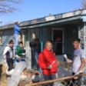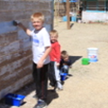

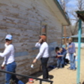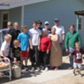
APRIL 2011

Families Served - 852

Along with being the Chairman of the Backyard Mission board, Jim Taylor leads the Bible Study Sunday School Class at LakeRidge UMC. Through Jim’s teaching and life example, these folks have learned what it means to live out the gospel and love your neighbor.
“Let us not love with word only, but with actions and truth.”
The Bible Study Class at LUMC does that well.

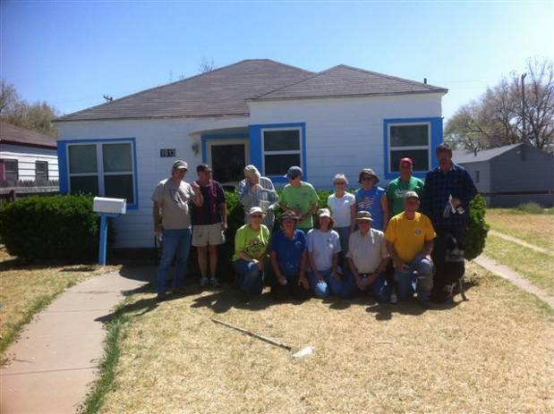

Thank you all for serving the Lord, by serving the poor.

Board Members:

Jim Taylor (chrmn) Jackson Ashburn Lindy Fruge’

Darrel Goss Glenn West

LAURIE FOSTER, Founder/Director
8205 Quincy Ave (806) 300-0184
Lubbock, TX 79424
Lfoster@backyardmission.org / www.backyardmission.org

2010-2011 Grants
Betenbough Homes. Monty Miller Living Legacy. LeGrande & Cassandra Northcutt Donor Advised Fund at East Texas Communities Foundation. Chester & Ada Ruth Green Charitable Endowment, W.B.Rushing & Mozelle Rushing Family Fund, H.D.Snell Endowment - all of the Lubbock Area Foundation, and Lubbock Area Foundation charitable funds.

