Backyard Mission
.…repairing homes, restoring hope….

Mission Statement:

1. Get people warm and dry by providing free home repairs, using volunteer labor and buying materials with donated money. Demonstrating the love of Christ!

2. Give Christians/Service groups the opportunity to put their belief into action, by loving and serving their neighbors.

3. Help other churches start a Backyard Mission program. ________________________________________________________

TIME PASSES

This past weekend, I drove through one of the first neighborhoods we worked in. It was a small pocket of extreme poverty. We were told it was one of the worst crack neighborhoods in Lubbock.

The homeowners we served were quite elderly and have long since passed away. I saw this weekend that the houses have been torn down too. Grass and prairie dogs now occupy the lots.

I remembered that two of the ladies made statements that were essential to setting our hearts right about ministry.

Pearl – walked around her house repeating, “Thank you Jesus for roofing my house.” My first thought was, “Well, we had a little to do with it”. Then immediately the Lord checked my heart. Nope. We are the body of Christ. Jesus is exactly who roofed her house, and if we took the focus off Him and put it on us, we were robbing Him.

Shirley – told us, “I love my new roof, but my favorite part is that you prayed for me.” Seriously? Of course! Most important is that people know God sees, knows, and loves them! We get to tell them that, because we are fixing their house, but the repairs are secondary to His love for them.

Thank you Lord for putting these two women in our lives, early in the ministry, so we kept the focus where it should be………..on You and Your love for Your children.
THE WITNESS IS YOURS!
APRIL 2018

Projects to date – 1478

The First United Methodist teams were hard at it this weekend, working on two homes!

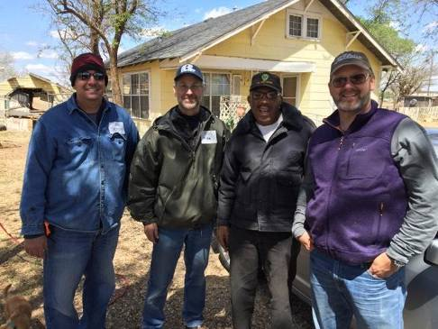

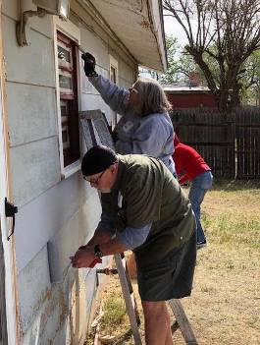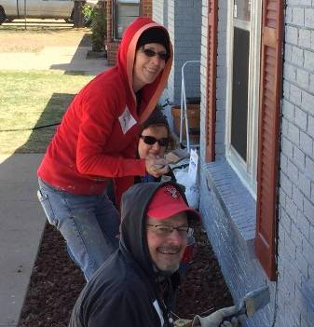

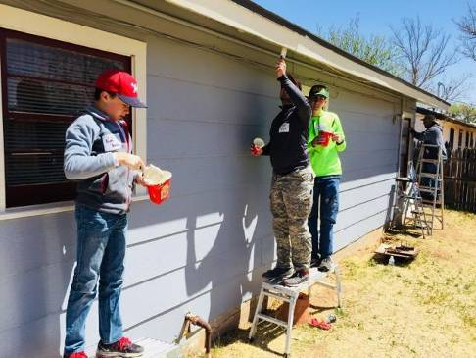

THANK YOU FUMC - LUBBOCK!!!
--------------------------------------------

Board Members:

Jim Taylor (chrmn) . Jackson Ashburn

Lindy Fruge’ Darrel Goss

LAURIE FOSTER, Founder/Director
8205 Quincy Ave (806) 300-0184
Lubbock, TX 79424 (land line)
Lfoster@backyardmission.org / www.backyardmission.org

