Backyard Mission
.…repairing homes, restoring hope….

Mission Statement:

1. Get people warm and dry by providing free home repairs, using volunteer labor and buying materials with donated money. Demonstrating the love of Christ!

2. Give Christians/Service groups the opportunity to put their belief into action, by loving and serving their neighbors.

3. Help other churches start a Backyard Mission program. ________________________________________________________

2017 has started well!

Several volunteer teams have contacted us to participate in our “adopt a house” program!

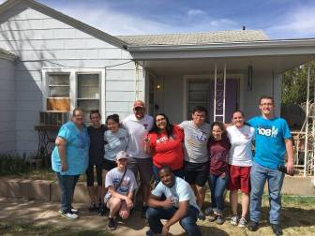

RHO – Raiders Helping Others – a Texas Tech team, painted a house this month. Great group of students! They learned a little about turtles too, from the homeowner! She had several in her flowerbed, just coming out of hibernation, much to everyone’s delight!

Living Stone Church is a new partner; they just completed their first project!

St. Luke’s UMC is jumping in to complete a house.

Aldersgate UMC picked up three to look at.
APRIL 2017

Projects to date – 1380

First United Methodist Church adopted four of our houses to complete this spring.

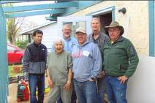

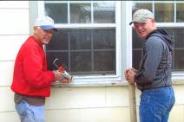

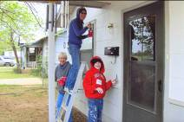

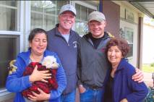

Board Members:

Jim Taylor (chrmn) . Jackson Ashburn

Lindy Fruge’ Darrel Goss

LAURIE FOSTER, Founder/Director
8205 Quincy Ave (806) 300-0184
Lubbock, TX 79424 (land line)
Lfoster@backyardmission.org / www.backyardmission.org

