Backyard Mission
.…repairing homes, restoring hope….

Mission Statement:

1. Get people warm and dry by providing free home repairs, using volunteer labor and buying materials with donated money. Demonstrating the love of Christ!

2. Give Christians/Service groups the opportunity to put their belief into action, by loving and serving their neighbors.

3. Help other churches start a Backyard Mission program. ________________________________________________________

JOY IN THE MIDST OF HARDSHIP

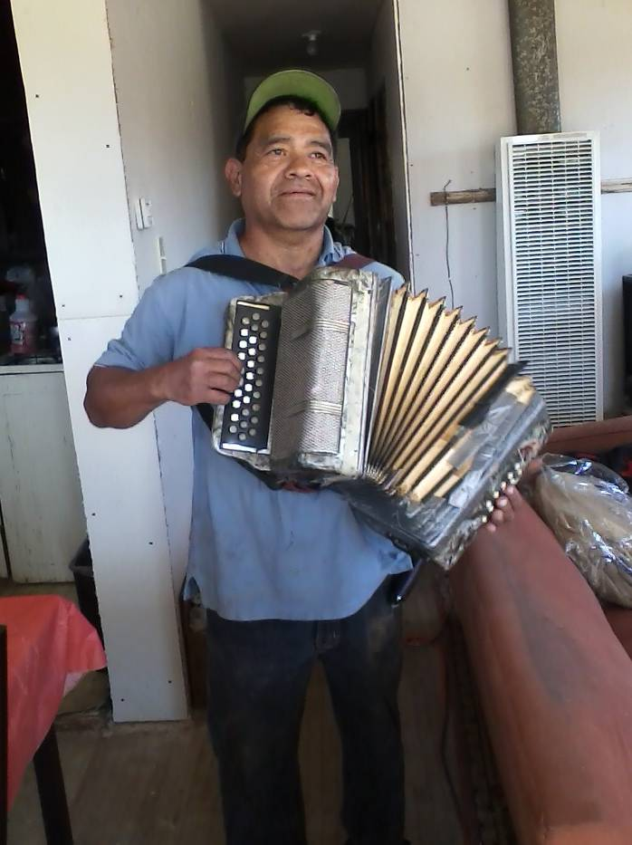

Meet my friend Daniel! We first started serving Daniel at the beginning of this year. He had a house fire over 2 years ago and had been living in his home with no electricity, one dangerous open flame heater, no insulation or sheetrock in living room or dining room, and a kitchen black with smoke damage. While we cannot do everything for him, the Backyard Mission Dream Team has been busy taking care of the warm and dry repairs we can do, and a few “above and beyond”.
Last week, he called us into his house and busted out a few songs on his accordion! IMPRESSIVE!
-Joy in the midst of hardship-
April 2015

Projects to date – 1193

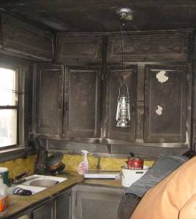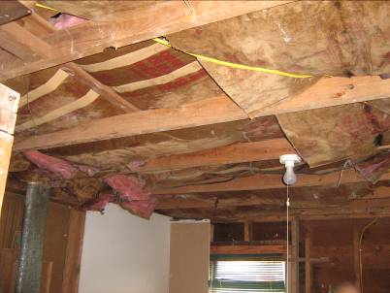
Material Poverty

Material poverty is pretty easy to recognize, and it is the outward need that we address through Backyard Mission. But when I hear the people we help say, “I love my new roof, but my favorite part was when you prayed for me.”; I know the condition of the human heart and spirit is God’s deepest concern.

As I leave my own middle-class neighborhood and head across town, I have this gnawing feeling and concern for the hidden poverty where I live:
- The crushing poverty of debt.
- The relentless poverty of busyness.
- The wounding poverty of broken families and relationships.

That kind of poverty is not so easy to recognize from the outside, but it burdens my heart as much as the material poverty I see in our Backyard Mission homes.
Jesus longs to reach in and restore life – abundant life – in all types of poverty.

------------------------------------------------------------------------------------
CONSIDER GIVING A DONATION IN HONOR/MEMORY OF SOMEONE THIS YEAR!

Board Members:

Jim Taylor (chrmn) Jackson Ashburn

Lindy Fruge’ Darrel Goss

LAURIE FOSTER, Founder/Director
8205 Quincy Ave (806) 300-0184
Lubbock, TX 79424
Lfoster@backyardmission.org / www.backyardmission.org

