Backyard Mission
.…repairing homes, restoring hope….

Mission Statement:

1. Get people warm and dry by providing free home repairs, using volunteer labor and buying materials with donated money. Demonstrating the love of Christ!

2. Give Christians/Service groups the opportunity to put their belief into action, by loving and serving their neighbors.

3. Help other churches start a Backyard Mission program. ________________________________________________________

SPRING BREAK 2014

We had a couple of groups work on Backyard Mission homes this spring break!

Scott Montgomery brought some youth from Wolfforth UMC, our neighbors to the west.
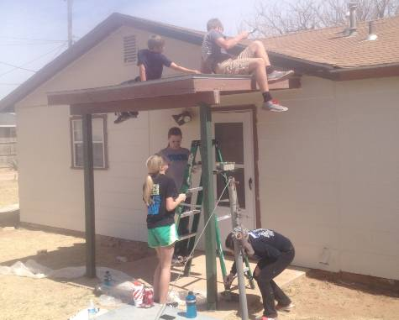
Scott is also starting a Backyard Mission program in Wolfforth, called “Restoration Ministries”. It will serve the town of Wolfforth and Frenship school district.
------------
Wesley Robinson and some other families from FUMC in Lubbock adopted a house as part of their spring break vacation fun!
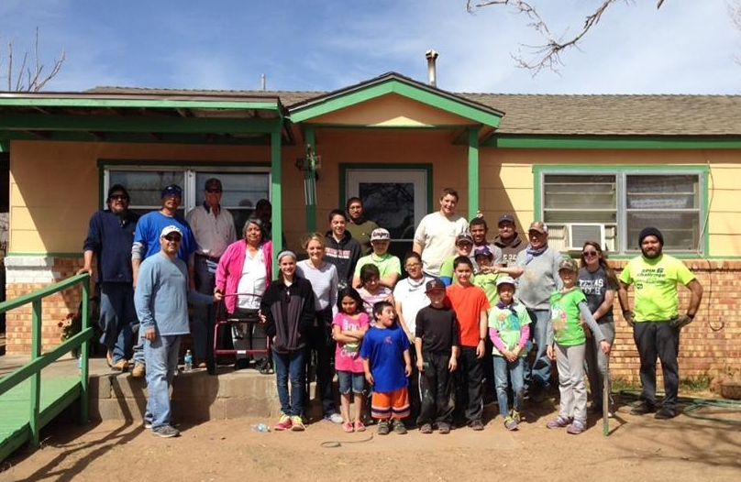
Thank you for loving your neighbors!
APRIL 2014

Projects to date - 1124

NEWS FROM “THE WELL”

In September of 2009, Betenbough Homes blessed Backyard Mission by giving us one of their former model homes for our offices. We named our new office “THE WELL”. We wanted the house to be more than office space. We wanted a place of worship, fellowship, and rest. Four ministries and one licensed counselor “live” at The Well. We also host outside bible study groups, staff meetings, and special events.
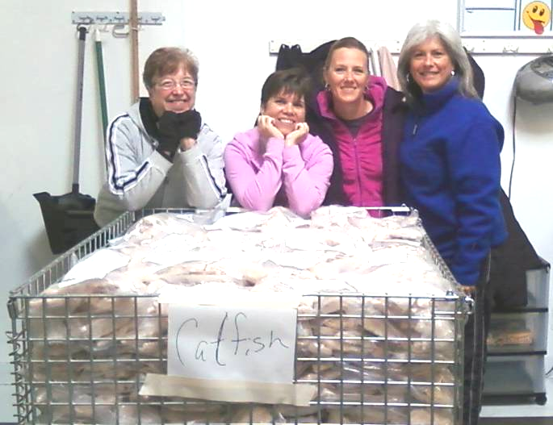
(left to right: Nita Kuehn, Lindy Fruge’, Angie Alspaugh, me)
As part of developing relationship with all who office here, we decided to volunteer together. On our first “outing”, we hit the South Plains Food Bank. We spent the morning taping boxes and sorting frozen catfish and chicken. (MaryKay McCauley Stone was on grandma duty)

THANK YOU BETENBOUGH HOMES! We hope we honor you, as well as the Father, as we share the blessing you gave to us with others. We are having a BLAST!

CONSIDER GIVING A DONATION IN HONOR/MEMORY OF SOMEONE THIS YEAR!

Board Members:

Jim Taylor (chrmn) Jackson Ashburn

Lindy Fruge’ Darrel Goss

Glenn West

LAURIE FOSTER, Founder/Director
8205 Quincy Ave (806) 300-0184
Lubbock, TX 79424
Lfoster@backyardmission.org / www.backyardmission.org

2013-2014 Grants
Betenbough Homes. Monty Miller Living Legacy. LeGrande & Cassandra Northcutt Donor Advised Fund at East Texas Communities Foundation, Chester & Ada Ruth Green Charitable Endowment, Mrs. Fern Cone Endowment, Roy & Lela Furr Fund, C.R. & Virginia Hutcheson Charitable Fund, Hassel Endowment, Horizon Fund and Gladys Leftwich Endowment, W.B. & Mozelle Rushing Family Endowment, and H.D. Snell Endowment, of Lubbock Area Foundation, and LAF charitable funds.

