Backyard Mission Newsletter…do the Word.

Mission Statement:

1. Get people warm and dry by providing free home repairs, using volunteer labor and buying materials with donated money. Demonstrating the love of Christ!

2. Give Christians the opportunity to put their faith into action by loving and serving their neighbors.

3. Help other churches start a Backyard Mission program in ____________________________________________

IT CONTINUES TO BE ABOUT GOD AND HIS LOVE……..

She is small, frail, and 79 years old. She has come to my office because she needs help with two exterior doors and a toilet. She is Spanish speaking, so a friend has come with her that can translate for us.

Even though she does not understand everything I say; she expresses her gratitude over and over again.

We complete our paper work, and as they stand to go, I ask if I can pray for them. This she understands, and with the joy of a child, she says “Yes!”, and wraps her arms around me and holds on. She is so small; she easily fits under my arm. I finish praying and she takes my face in her hands, kisses my cheek, and thanks us one last time. I assure her that God sees her, loves her, and is happy to meet her needs.

Once again God reminds me that it is always about His love for His people, and we have the honor of living that out.

“Love God, and love your neighbor.” Can it really be that simple? Absolutely.
APRIL 2012

Families Served - 935

The HEIGHTS FELLOWSHIP “adopted” one of our homes in March. Shannon Morrison, team leader, reported: “On Saturday afternoon several members of The Heights Fellowship came together to show some neighborly love to “Mrs. C”. The job included scraping and painting her home which was in desperate need of TLC. Everyone had a great time working together, and we are all thankful for the opportunity to work with backyard mission, and look forward to future projects.”
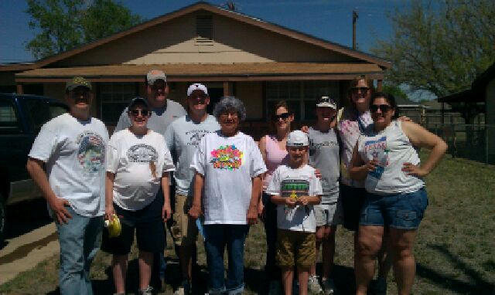
WELCOME TO THE WELL!
We are excited to add two new ministries to our office in 2012. Angie Alspaugh and husband Terry, founders of “Easy R Equine Rescue”, and Nita Kuehn and husband John, founders of “Walking in Freedom Ministries”. Go to: www.easyrequinerescue.org, and www.walkinginfreedom.org.

Board Members:

Jim Taylor (chrmn) Jackson Ashburn Lindy Fruge’ Glenn West

Darrel Goss

LAURIE FOSTER, Founder/Director
8205 Quincy Ave (806) 300-0184
Lubbock, TX 79424
Lfoster@backyardmission.org / www.backyardmission.org

2011-2012 Grants
Betenbough Homes. Monty Miller Living Legacy. LeGrande & Cassandra Northcutt Donor Advised Fund at East Texas Communities Foundation. Chester & Ada Ruth Green Charitable Endowment, Mrs. Fern Cone Endowment, Roy & Lela Furr Fund, C.R. & Virginia Hutcheson Charitable Fund, Hassel Endowment, Horizon Fund, Gladys Leftwich Endowment, W.B.Rushing & Mozelle Rushing Family Fund, H.D.Snell Endowment - all of the Lubbock Area Foundation, and Lubbock Area Foundation charitable funds.

