Backyard Mission Newsletter…do the Word.

Mission Statement:

1. Get people warm and dry by providing free home repairs, using volunteer labor and buying materials with donated money. Demonstrating the love of Christ!

2. Give Christians the opportunity to put their faith into action by loving and serving their neighbors.

3. Help other churches start a Backyard Mission program in their community.
____________________________________________

SPRING IS IN THE AIR

The weather is warming up and churches are coming to the office to select projects to “adopt”. We have already had four local churches come and pick out one or more homes to repair this spring.

Check out our Second Baptist Team:

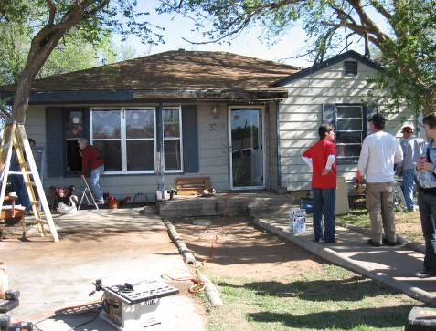

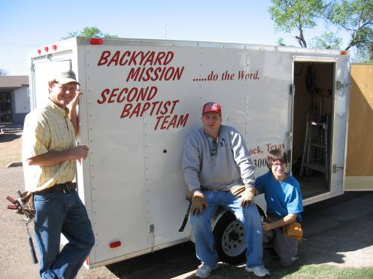

This fulfills our mission to be a resource to others who want to be involved in outreach to their neighbors.
APRIL 2010

Families Served - 769

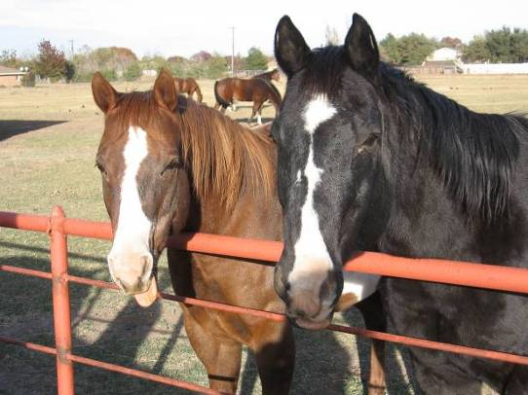

Often God uses His creation to reveal Himself to me. I happen to have a horse story to share about that.……..

Levi, my horse, and Chief, are BFFs. “Best friends forever” in the texting world; a “bonded pair” in the horse world.

One afternoon, as I pulled up to the barn, I saw Chief, lying flat, sleeping. Levi was standing over him as he slept. In the herd, often while one horse sleeps (which is a very vulnerable position), another will stand guard or keep watch.

Psalm 121 is one of my favorite scriptures. In that chapter is a verse that says……….”He who watches over you will not slumber; indeed, he who watches over Israel will neither slumber nor sleep.”

Levi, standing over Chief as he slept, was a great illustration of the watchfulness of God over our lives.

** A big thanks to Alamo Remodeling for providing
a dump truck for us!! **

Board Members:

Jim Taylor (chrmn) Jackson Ashburn Lindy Fruge’

Darrel Goss Sheri Haynes Glenn West

LAURIE FOSTER, Founder/Director
8205 Quincy Ave (806) 300-0184
Lubbock, TX 79424
Lfoster@backyardmission.org / www.backyardmission.org

2010 Grants
Betenbough Homes

